***SINGHANIA EDUCATIONAL INSTITUTE***

Computer Science

Practical File 2023-24

**Name:**

**Class: Section:**

**Roll no:**

**Under the Guidance of:**

**Mr.Mohd Imran Khan**

**PGT (COMPUTER SCIENCE)**

**ACKNOWLEDGEMENT**

I would like to express a deep sense of thanks & gratitude to my project guide Mr. Imran Khan for guiding me immensely through the course of the project. He always evinced keen interest in my work. His constructive advice & constant motivation have been responsible for the successful completion of this project.

My sincere thanks goesto Mr. Harish Choudhary, Our principal sir, for his co-ordination in extending every possible support for the completion of this project.

I also thank my parents for their motivation & support. I must thank my classmates for their timely help & support for compilation of this project.

INTRODUCTION

This is a programme that processes the way a shop works and has been made by integrating the MYSQL database with Python (My SQL connector ) which presents this project in an easy and understandable way . This project also shows the application of Database Management System in python using My SQL and My SQL connector.

This program allows the user to view the available products , delete a product form the menu , search the database for a particular product , add a new product and update the cost and id of a product .

It also performs the task of billing and automatically stores the data in a new table in order to keep a record of the transactions .

Program

import mysql.connector

c=mysql.connector.connect(host="localhost",user="root",passwd="1234",database="BAKERY")

d=c.cursor()

def create_t():

d.execute("create table Your_Cart(Product char(10),Cost int(3), Id int(3),Quantity int(2))")

c.commit()

def search_prod():

a=input("Enter product name to be searched for: ")

d.execute("select * from Product where Product='{}'".format(a))

print(33*'_')

print("%s%10s%3s%10s%3s%3s%3s"%('|','Item','|','Cost','|','Id','|'))

print(33*'=')

for i in d:

print("%s%10s%3s%10s%3s%3s%3s"%('|',i[0],'|',i[1],'|',i[2],'|'))

print(33*'-')

def search_cost():

f=int(input("Enter minimum cost of product: "))

d.execute("select * from product where cost>={}".format(f))

print(33*'_')

print("%s%10s%3s%10s%3s%3s%3s"%('|','Item','|','Cost','|','Id','|'))

print(33*'=')

for i in d:

print("%s%10s%3s%10s%3s%3s%3s"%('|',i[0],'|',i[1],'|',i[2],'|'))

print(33*'-')

def disp_prod():

d.execute("select * from Product")

print(33*'_')

print("%s%10s%3s%10s%3s%3s%3s"%('|','Item','|','Cost','|','Id','|'))

print(33*'=')

for i in d:

print("%s%10s%3s%10s%3s%3s%3s"%('|',i[0],'|',i[1],'|',i[2],'|'))

print(33*'-')

def customer_info():

d.execute("select*from customer")

print(105*'_')

print("%s%15s%3s%50s%3s%12s%3s%15s%3s"%('|','Customer Id','|','Products','|','Total Qty','|','Grand Total','|'))

print(105*'=')

for i in d:

print("%s%15s%3s%50s%3s%12s%3s%15s%3s"%('|',i[0],'|',i[1],'|',i[2],'|',i[3],'|'))

print(105*'-')

def update_cost():

cost1=int(input("Enter new cost: "))

id1=int(input('Enter id of product to update cost: '))

d.execute("update product set Cost={} where Product_id={}".format(cost1,id1))

c.commit()

def delete_item():

d.execute("select * from Product")

print(33*'_')

print("%s%10s%3s%10s%3s%3s%3s"%('|','Item','|','Cost','|','Id','|'))

print(33*'=')

for i in d:

print("%s%10s%3s%10s%3s%3s%3s"%('|',i[0],'|',i[1],'|',i[2],'|'))

print(33*'-')

id2=int(input('Enter id of product to be deleted: '))

d.execute("delete from product where Product_id={}".format(id2))

c.commit()

def add_new_item():

P_name=input("Enter product name: ")

cost2=int(input("Enter cost of product: "))

id3=int(input("Enter id of product: "))

d.execute("insert into product values('{}',{},{})".format(P_name,cost2,id3))

c.commit()

def bill():

all_prod=""

gt=0

qty1=0

while True:

print("1.Cake")

print("2.Pastry")

print("3.Biscuits")

print("4.Bread")

print("5.Muffin")

print("6.Donut")

t=0

ch=int(input("Enter choice: "))

d.execute("select * from product where Product_id={}".format(ch))

qty=int(input("Enter Quantity: "))

for i in d:

product=i[0]

cost=i[1]

total=qty*cost

d.execute("insert into Cart values('{}',{},{},{})".format(product,cost,qty,total))

kk=input("Want to purchase yes or no: ")

gt=gt+total

all_prod=product+','+all_prod

qty1=qty1+qty

if kk=='no':

break

print("---------------List Of Your Products----------------")

print(52*'_')

d.execute("select * from Cart")

print("%s%15s%3s%7s%3s%10s%3s%7s%3s"%('|','Products','|','Cost','|','Quantity','|','Total','|'))

print(52*'=')

for i in d:

print("%s%15s%3s%7s%3s%10s%3s%7s%3s"%('|',i[0],'|',i[1],'|',i[2],'|',i[3],'|'))

print(52*'-')

print("Total Quantity: ",qty1)

print("Your Grand Total is: ",gt)

p_id=int(input('Enter customer id: '))

d.execute("insert into customer values({},'{}',{},{})".format(p_id,all_prod,qty1,gt))

c.commit()

print('WELCOME TO THE BAKERY SHOP')

while True:

print("1.Display ")

print("2.Delete ")

print("3.Search")

print("4.Update")

print("5.Purchase")

print("6.Exit")

hh=int(input("Enter your choice: "))

if hh==1:

print("1.Display menu")

print("2.Display customer info")

dd=int(input("Enter your choice: "))

if dd==1:

disp_prod()

elif dd==2:

customer_info()

elif hh==2:

delete_item()

elif hh==3:

print("1.Search by Name")

print("2.Search by Cost")

dd=int(input("Enter ur choice: "))

if dd==1:

search_prod()

elif dd==2:

search_cost()

elif hh==4:

print("1.Update Cost")

print("2.Add new item")

df=int(input("Enter your choice: "))

if df==1:

update_cost()

elif df==2:

add_new_item()

elif hh==5:

bill()

elif hh==6:

print("Thank You for Visiting")

break

c.close()

Output

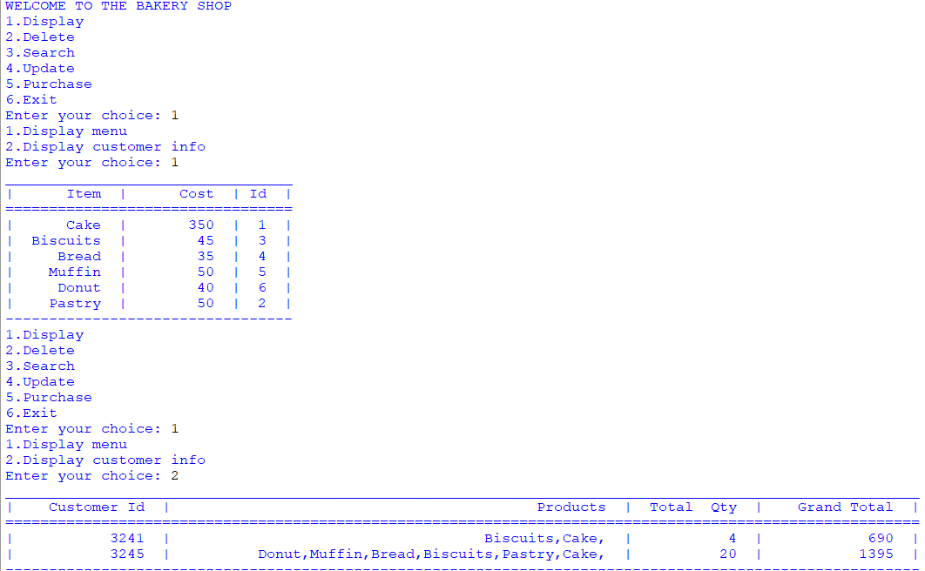Displays Menu and Customer Info

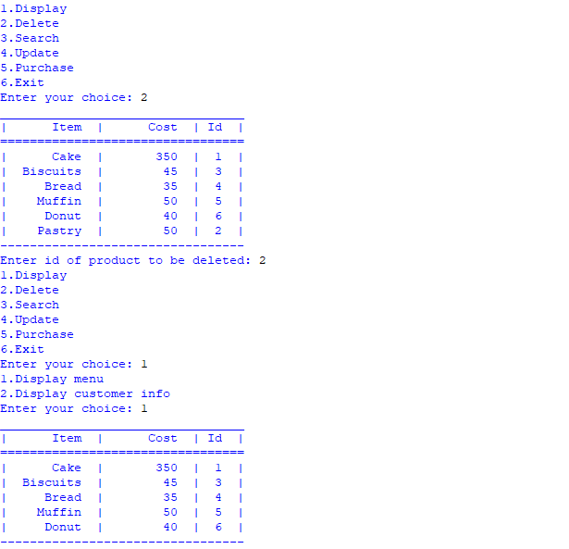Deleting a Product

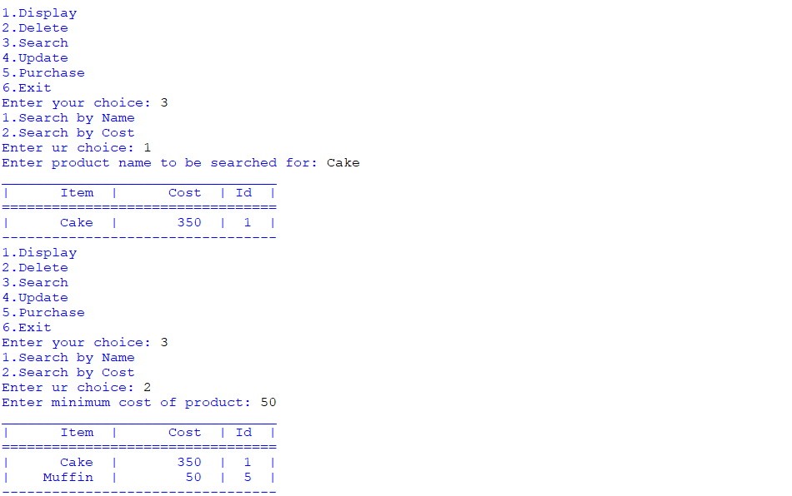Searching Product by Name and Cost

Adding new product

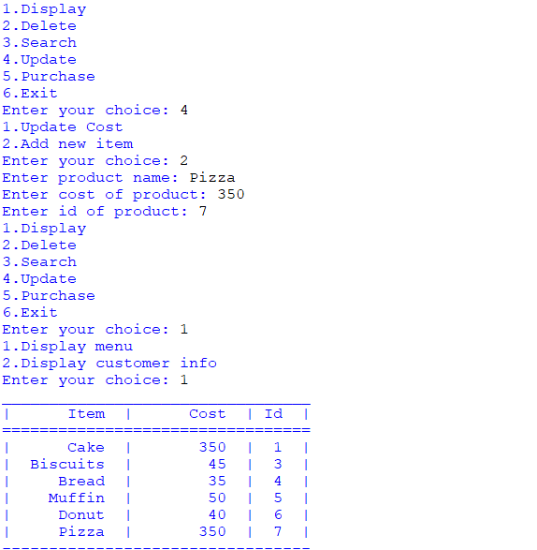

Updating Cost of Product

Initial Table

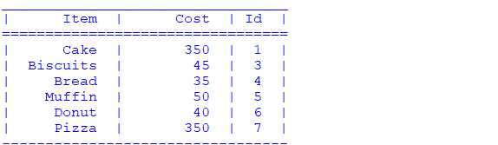

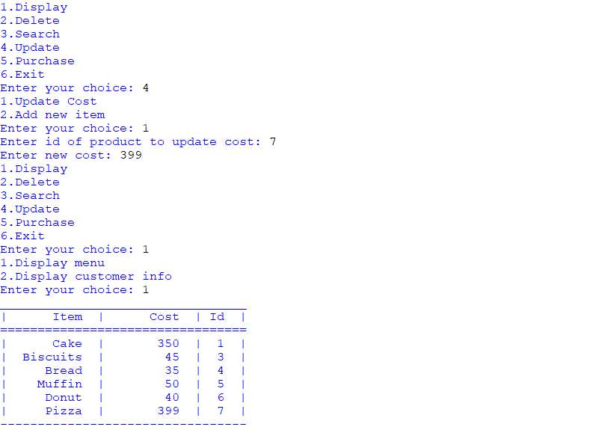After updating cost

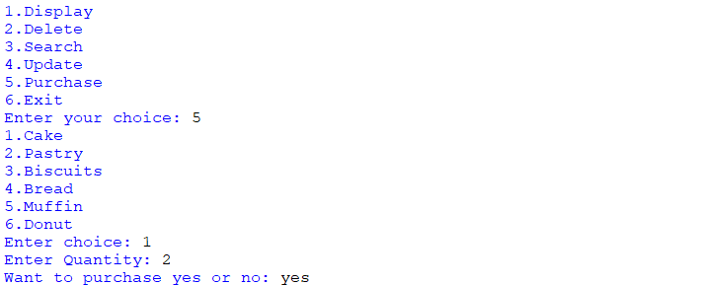Purchasing and Billing

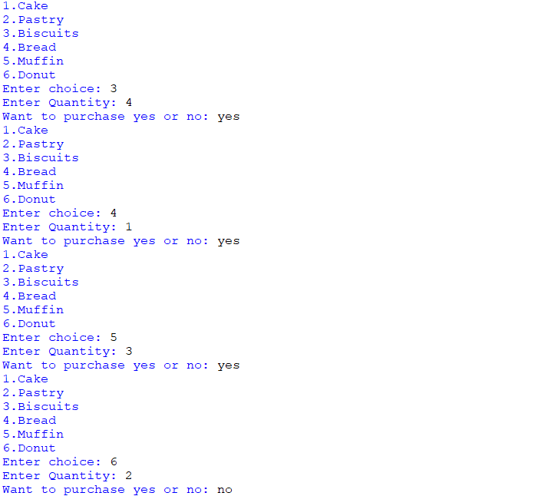

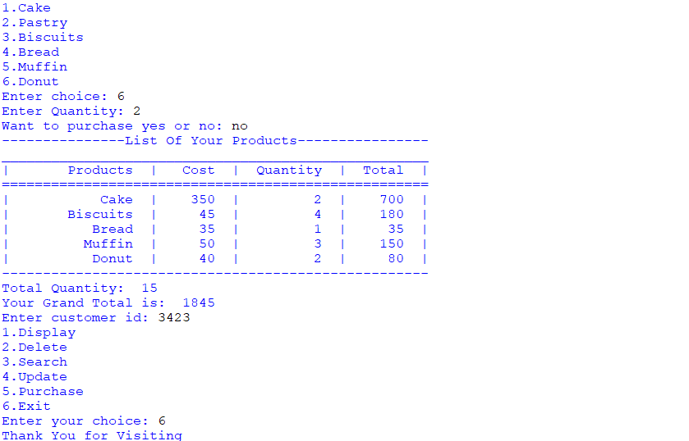

**Bibliography**

* Computer Science with Sumita Arora
* Computer Science with Preeti Arora
* www.w3resource.com
* Under the guidance of subject teacher